Eric Penrose, Lance Weston, Reneise White

9/12/2020

Project 1

Written Report

1. How many movies in horror, romance, and sci-fi genres are released each year?

This is important to look at before we dive into box office total revenue because if there are more movies released in a particular genre than it would be expected that the box office revenue would be higher, especially during “peak-season”.This line graph has three genres (horror, romance, and sci-fi) looking at the total number of movies released by year. It was found that romance has the highest number of movies released. Whether this is due to romance as a stand alone genre or due to our data set including romantic-comedies or romantic-family movies together is something we do not know. The next thing we can pull from this data is that horror films drop and rise depending on the years. Sci-fi movies tend to be stable throughout the years.

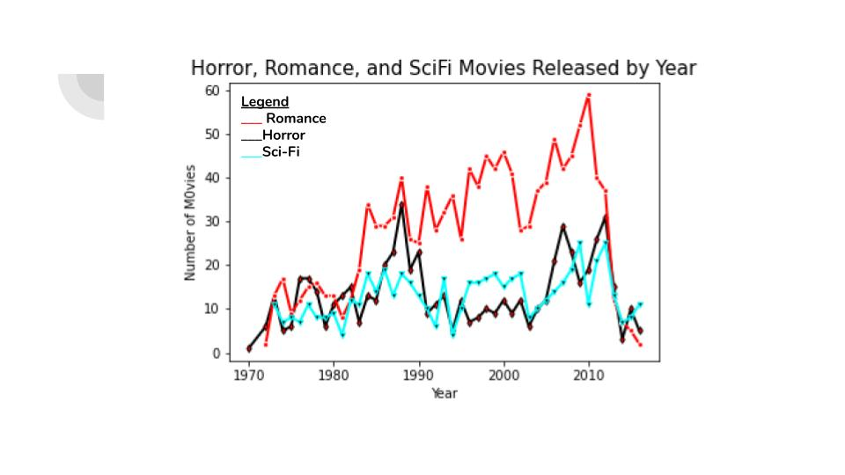

1. How are the box office totals changing for these genres over the years?

An immediate limitation we noticed of our API while creating these graphs is that box office totals begin in the early 2000s. This shows bias of box office reporting because there are box office totals for movies before the early 2000s but that data was not included in our dataset. From the first question it is known that the number of films released for horror over the years fluctuates so it is expected that the same trend is seen here.

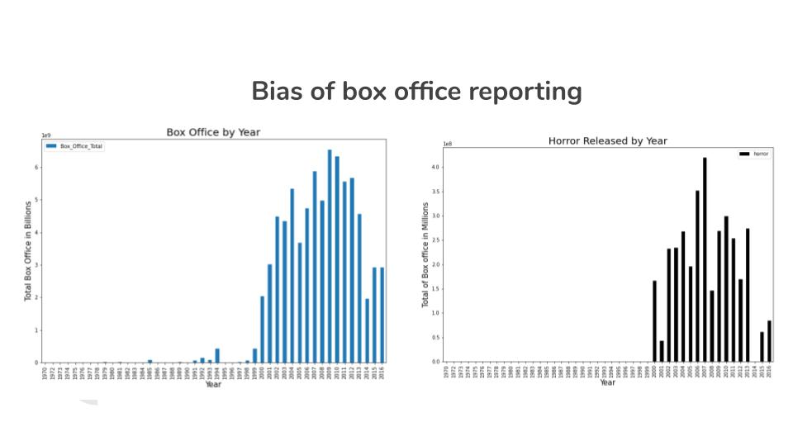

1. Is there any difference in box office totals of movies that are released during their “peak season” vs. being released any other time of the year?

It was found that horror movies typically do better in October, as expected. Romance movies typically do better in february, may and june.Sci-fi typically does better in June which is not something that was expected. This data tells us that there are particular months throughout the year that movies are released because they do better at the box office. Another important thing to note is that the box office totals for horror and sci-fi are in the hundreds of millions while romance is in the billions. The second set of graphs are looking at imbd ratings of movies in horror, romance, and sci-fi which is stable across the years. The last graph is correlating the box office totals to the imdb rating of movies. This scatter plot does prove that there is a positive correlation with box office totals and imdb ratings of movies.

